DO­­3SE Interface 2.0

User Documentation

# Basic concepts

The DO3SE interface provides a way to parameterise and run the DO3SE model without the need to edit and recompile Fortran code.

## Project files

Any dataset that is to be run through the DO3SE model is going to have a parameterisation associated with it. The purpose of a “project file” is to store all of these parameters together in a single file. This means that a project file along with its corresponding input dataset can be given to another person who has the DO3SE interface so they can run it and get the same results. The file name of a project file should end in .do3se.E interface "oue"a project file along with it's corresponding input dataset can be given to another person who has the DOparam

## Presets

A project file contains all the parameters for running a dataset, however sometimes it is desirable to re-use a certain subset of the parameters in other projects, for example those which characterise a particular species. A preset is a collection of parameters saved under a name, and can be “applied” to a project, replacing the values of those parameters.

## Data files

All input and output datasets are CSV (comma-separated values) files, since this is the most portable format to work with. If you have your input data in an Excel (.xls) file, you can create a CSV file by opening it in Excel and using the “Save as...” dialog, changing the type to “CSV (Comma delimited) (*.csv)”. CSV files can be opened in Excel without any additional work.

## Workflow

Here is a basic workflow for running a new project with the DO3SE interface.

* Open the DO3SE interface and click “New project”.
* On the “Input data format” page, select and arrange fields until they match the order of the columns in your input file. *If the units of a field do not match the units in the dataset, the data must first be converted before it can be used with the interface.* Set the trim value to the number of non-data rows at the beginning of the file.
* Navigate to each page, setting the parameters values as necessary. If one of the supplied default vegetation parameterisations is desired, open the preset manager (using the “Manage/apply preset” entry in the “Tools” menu), select the preset and apply it.
* Check that there are no errors indicated in at the bottom of the project window. If there are, click the errors button to see where the problems are and correct them.
* Save the project.
* If there are no errors, the “Run” button should be enabled. Click it and select the CSV file to use as the input dataset. The model will now run, showing its progress in the progress bar at the bottom of the window.
* In the output window that opens when the model has finished running, go to the “Save to file” tab. Select which output columns to save (this works the same as the “Input data format” page) and click “Save As...” to specify where to save the output dataset. This dataset can now be opened in a spreadsheet program for further work.

# The “Welcome” screen

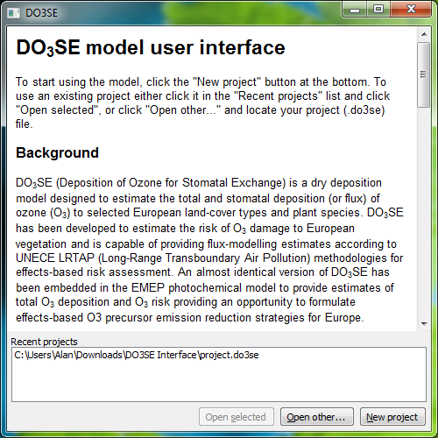

The welcome screen is the first screen that appears when the DO3SE user interface is launched. The top part of the window provides an introduction to the DO3SE model. Next is a list of recently-opened projects for quick access to frequently-used project files. The “Open selected” button is enabled when a recent project is selected, and will cause a window to be opened for that project. The “Open other...” button will ask you to locate a project file to open. The “New project” button will open a project window with all parameters set to their defaults.

# The “Project” screen

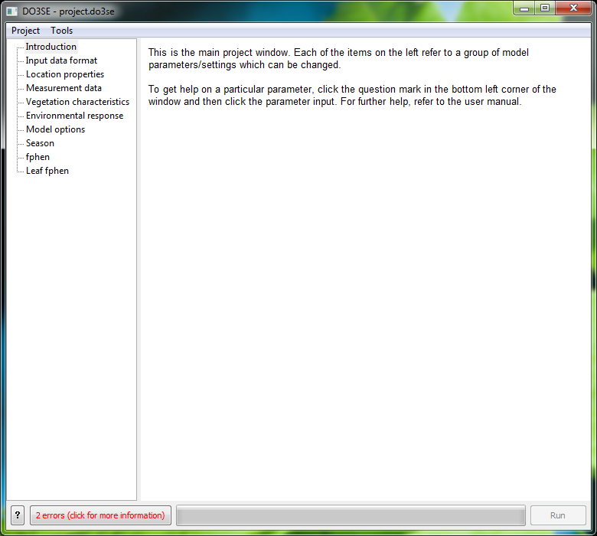

(1)

(6)

(5)

(4)

(3)

(2)

Each project that is currently open will be represented by a project window. This window provides access to all of the model parameters for the project. The window has the following main elements:

1. The title bar. Contains the name of the project file if it exists on disk. If the * symbol is at the beginning of the title bar, changes have been made which need to be saved.
2. The page selector. Clicking one of these items will open the corresponding parameter page on the right-hand-side panel.
3. The context help button. To get more information about an input, click this button and then the input; if there is any extra help information associated with the input, a tooltip will pop up displaying it.
4. The errors button. Shows a count of the problems that exist in the current project (not all combinations of parameter values are valid). Click this button to show/hide the list of errors (see image below).
5. The run button. Prompts for an input data file and runs the model with this project’s parameters. Only enabled when there are no errors in the parameters.
6. The progress bar. Shows progress through the model run when the model is being run.

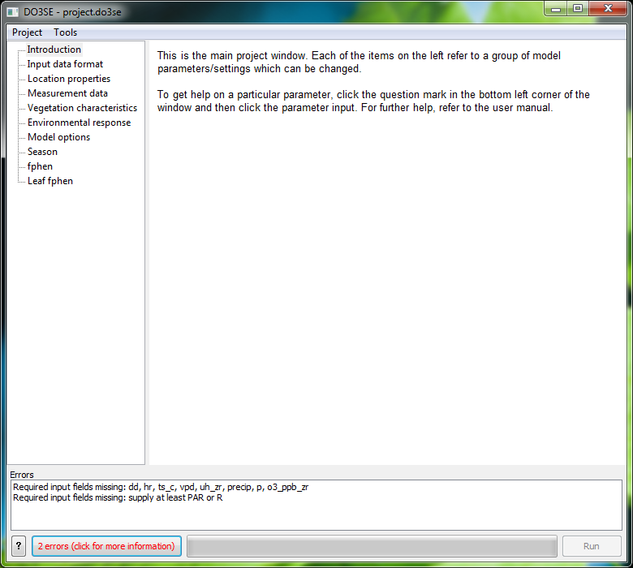

## The “Input data format” page

This page is used to tell the program which columns in your input data correspond to which input field for the model. Special care should be taken to ensure the units specified in the column list match those in your input data. Entries on the left are available columns and entries on the right are columns that have been selected. To add a column, select it on the left and click “Add”. To remove a column, select it on the right and click “Remove”. To rearrange the columns, select the column on the right and use the “Up” and “Down” buttons to move it.

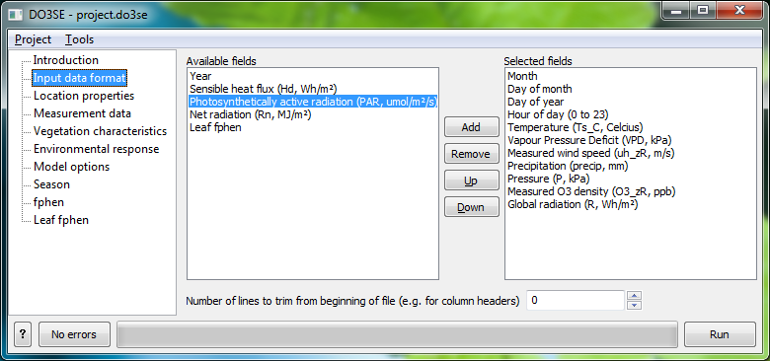

The “Number of lines to trim...” input specifies how many rows should be ignored at the beginning of the file. This allows input data files to have column headers/descriptions and for these to not be treated as data by the model. Certain fields are required, and if they are not selected an error will be displayed, preventing the model from being run.

## The “Location properties” page

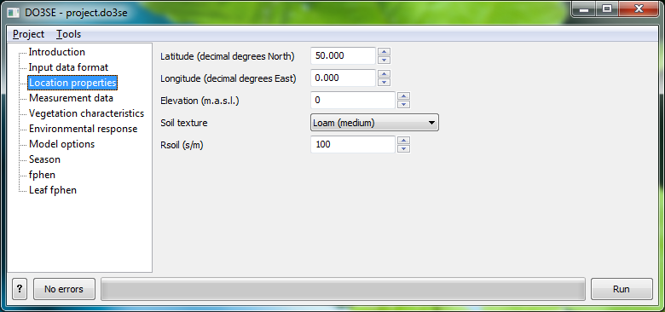

This page contains parameters relating to the location the dataset is from. Note that the latitude and longitude are specified in decimal degrees, not degrees, minutes and seconds.

## The “Measurement data” page

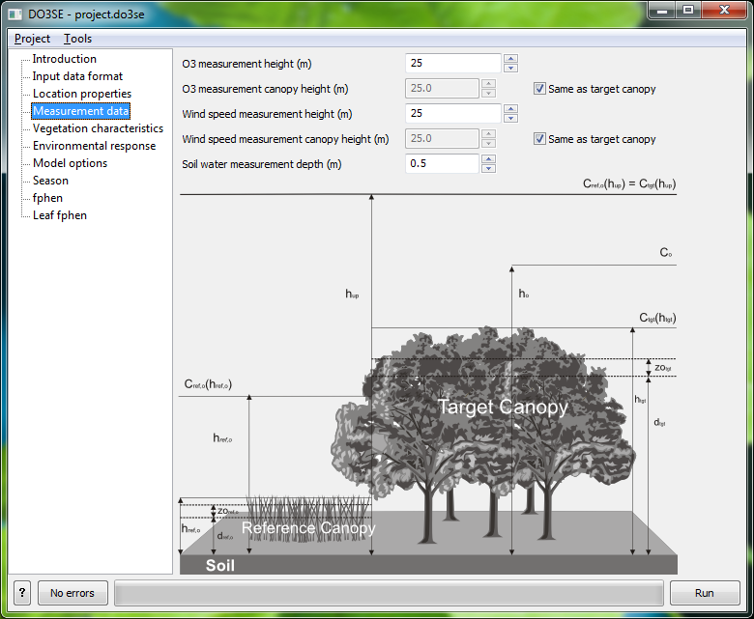

This page contains parameters relating to where measurements were obtained. For O3 and wind speed measurements, both the height at which the data was measured and the height of the vegetation where it was measured are required. If the “Same as target canopy” checkbox is checked the model will assume that the data was measured over the canopy for which the model is being run.

The “Soil water measurement depth” allows the model to calculate soil water data for a particular depth which can then be compared with real-world data.

## The “Vegetation characteristics” page

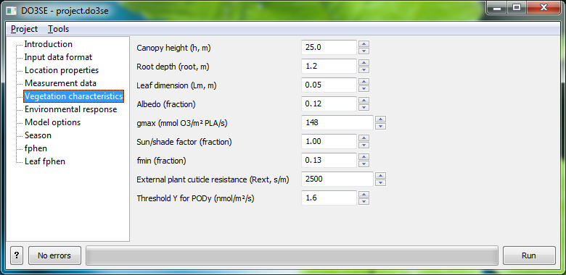

This page contains various vegetation-specific parameters. The meaning of each parameter is explained in the DO3SE model documentation.

## The “Environmental response” page

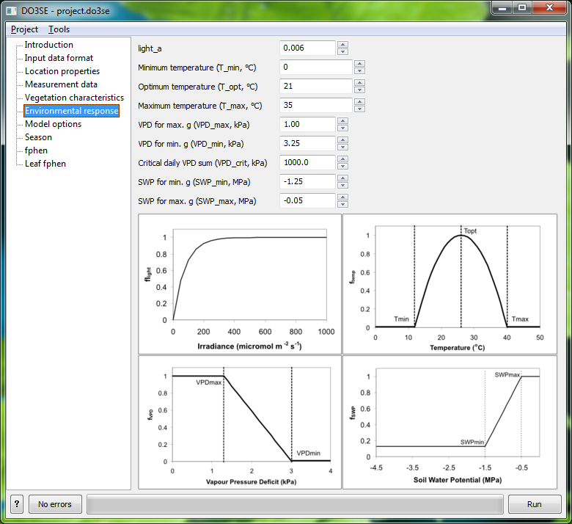

This page contains parameters for certain “response functions” that depend on environmental parameters. The images at the bottom illustrate the response functions and what the parameters correspond to.

## The “Model options” page

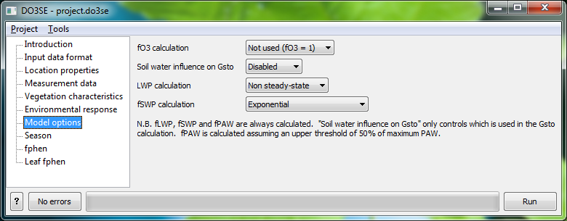

A few parts of the model can either be disabled or have several different methods for calculating the same factor. The “Model options” page is for configuring these parts.

### fO3 calculation

Selects whether or not to include the fO3 method in the calculation of leaf G­sto.

### Soil water influence on Gsto

There are 3 different ways of calculating the effect of soil water availability on stomatal conductance supported by the interface: soil water potential (fSWP), leaf water potential (fLWP) and plant available water (fPAW). The model always calculates all 3 of these, but this option selects which one to use when calculating Gsto. The other option, “Disabled”, removes all soil water influence from the Gsto calculation.

### LWP calculation

Selects between 2 methods for calculating LWP: a steady-state model or a non-steady-state model.

### fSWP calculation

Selects between 2 methods for calculating fSWP from soil water potential: an exponential curve or a linear function based on SWPmin and SWPmax.

## The “Season” page

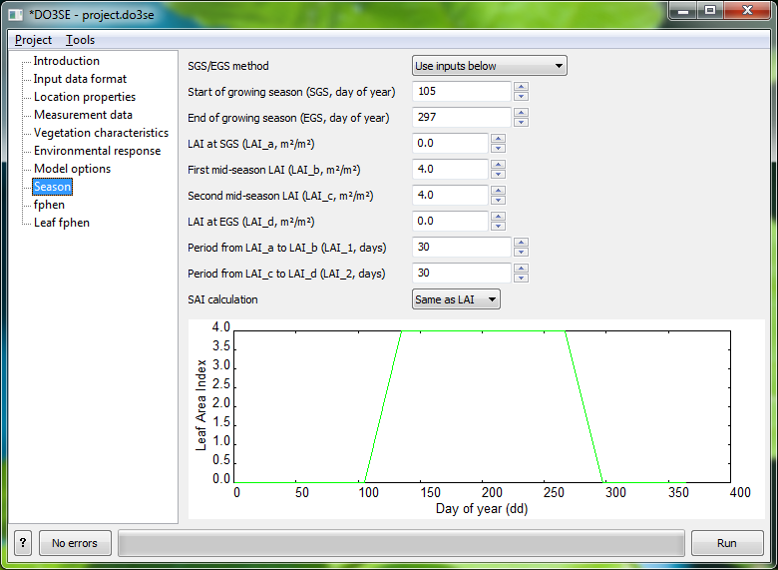

This page is for setting the growing season (SGS/EGS) and configuring the leaf area index (LAI) and stand area index (SAI) functions. At the bottom is a preview graph for the LAI function to aid with setting the parameters. If the line crosses itself or goes backwards at any point, this is an indication that the parameters are incorrect.

If the “SGS/EGS method” is switched to “Latitude function (forests)”, SGS and EGS will be calculated using the forest latitude model

## The “fphen” page

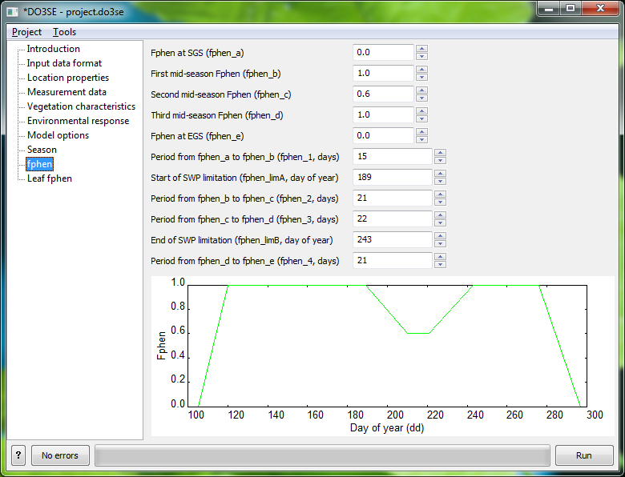

This page is for configuring the Fphen function. A live preview is provided at the bottom to help with configuration. Things to look out for when configuring the Fphen function are the same as with the LAI function. If fphen_limA and fphen_limB are set to 0, the model reverts to a “simpler” version which doesn’t have the “dip” in the middle.

## The “Leaf fphen” page

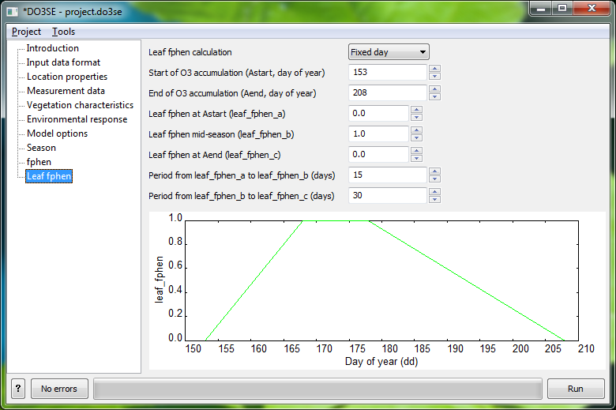

This page is for configuring the leaf_fphen function, if it should be different from the Fphen function. For more complex methods (e.g. the thermal time model) it is possible to supply leaf_fphen values which have been calculated beforehand. To do this, the leaf_fphen values should be in the input dataset file, the “Leaf fphen” column needs to be added on the “Input data format” page and “Leaf fphen calculation” on this page should be set to “Use input”.

# Creating and managing presets

A project file contains all the parameters for running a dataset, however sometimes it is desirable to re-use a certain subset of the parameters in other projects, for example those which characterise a particular species. A preset is a collection of parameters saved under a name, and can be “applied” to a project, replacing the values of those parameters.

A new preset can be created from the current project by using the “Create preset” dialog, accessible from the “Tools” menu. Applying or deleting a preset can be done in the “Manage/apply presets” dialog, also accessible from the “Tools menu”.

## The “Create preset” dialog

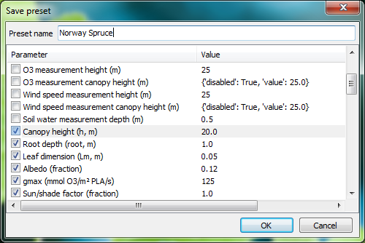

This window allows the creation of a new preset from the current project’s parameters. By default, no parameters are selected. The checkbox next to each parameter that should be added to the preset should be checked, and a name for the preset supplied, before clicking “OK”.

## The “Manage/apply presets” dialog

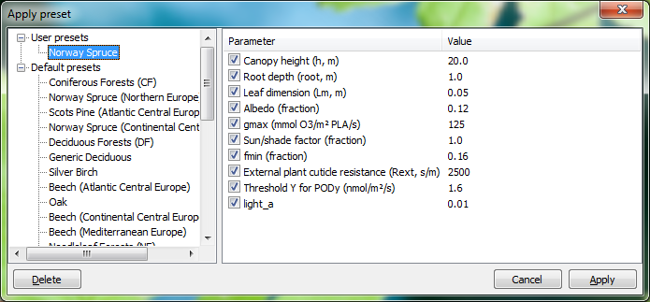

This window shows all of the existing presets, split into two groups:

* “User presets” – presets which have been created using the “Create preset” dialog.
* “Default presets” – supplied by the DO3SE interface and correspond to species parameters in the DO3SE model documentation.

User presets can be deleted by selecting them in preset list on the left and clicking the “Delete” button. It’s not possible to delete an interface-supplied preset.

When a preset has been selected on the left, the parameters it supplies are shown on the right. Clicking “Apply” will set those parameters to the specified values in the current project. Undesired parameters can be skipped by making sure the checkboxes next to them are not ticked.

# The “Results” screen

Once the model has been successfully run, the results will be displayed in a results window.

## The “Data” tab

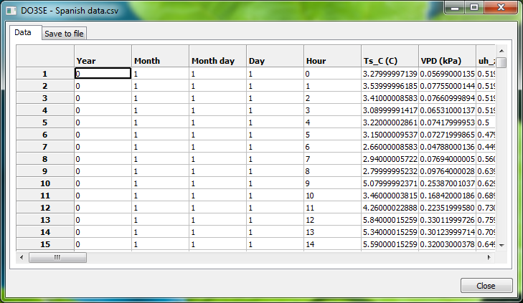

The “Data” tab allows the output data to be previewed before saving it to a file.

## The “Save to file” tab

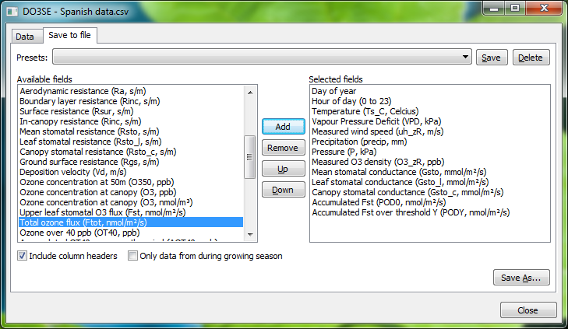

On the “Save to file” tab it is possible to select which columns to save. If a particular output configuration is regularly used, it can be saved as a preset by clicking the “Save” button next to the presets drop-down. To load a configuration, click it in the presets drop-down. Clicking “Save As...” will prompt for a location and filename and save the output data according to the current configuration.